Assignment 2.4
Name: Zobiya Fatima
Batch No: 14
Hall Ticket No: 2303A51879

Task 1: Book Class Generation
- Scenario:You are building a simple library management module.
- Task: Use Cursor AI to generate a Python class Book with attributes title, author,and a summary() method.
- Expected Output:
- Generated class
- Student commentary on code quality
Code:
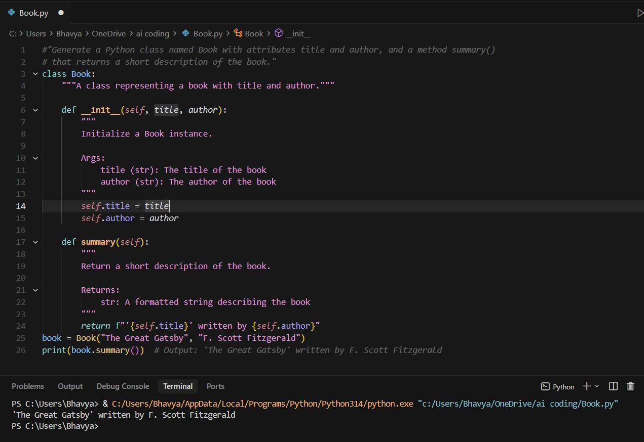

Conclusion:
This program is used to store book details like title and author in a single unit. The class helps create multiple book objects without rewriting code.
The summary function prints book information in a clear and fixed format. The main block runs the program and shows the output for different books.

Task 2: Sorting Dictionaries with AI
- Scenario:You need to sort user records by age.
- Task:Use Gemini and Cursor AI to generate code that sorts a list of dictionaries by a key.
- Expected Output:
- Both AI outputs
- Comparison of clarity and performance
CODE FROM GEMINI:
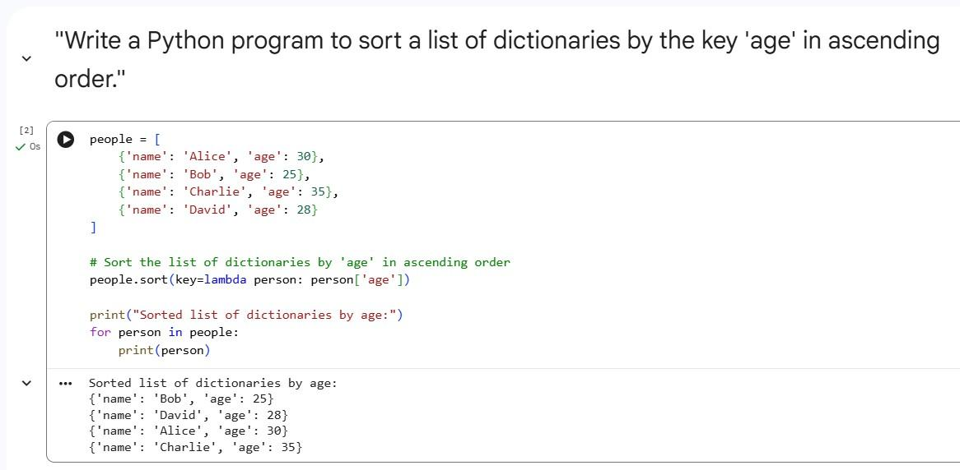
CODE FROM CURSOR AI:
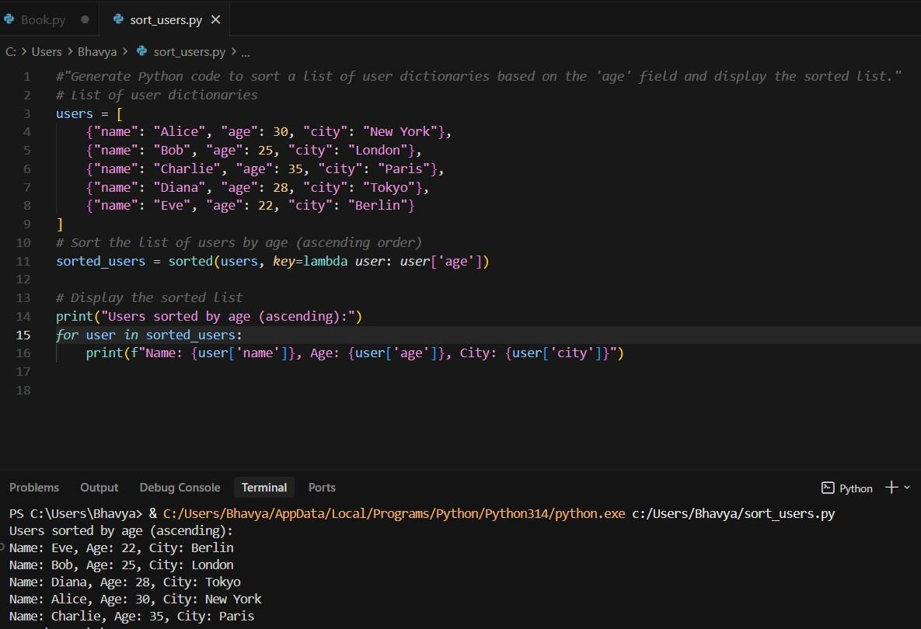
Conclusion:
Both tools generated correct and efficient code. Cursor AI used in- place sorting, which is more memory efficient.

Task 3: Calculator Using Functions
- Scenario:You are reviewing a basic calculator module.
- Task:Ask Gemini to generate a calculator using functions and explain how it works.
- Expected Output:
- Calculator code ➢ AI explanation
CODE:

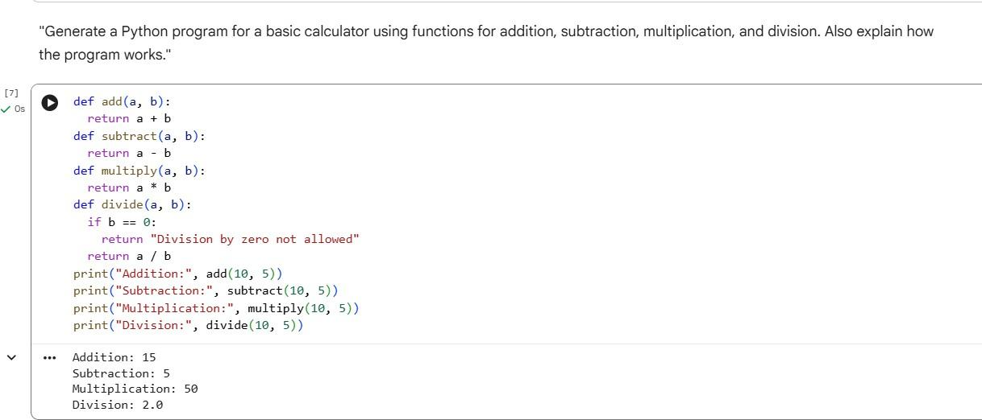
AI Explanation Summary:
  - Separate functions are created for each operation.
  - Each function performs a single responsibility.
  - Division function checks for division by zero.
  - Main program calls each function and prints the result.
Student Analysis:
  - Code is modular and easy to understand.
  - Proper error handling for division by zero.
  - Functions can be reused in larger applications.
Conclusion:
Gemini produced a clear, well-documented functional program with proper explanations.

Task 4: Armstrong Number Optimization:
- Scenario:An existing solution is inefficient.
- Task:Generate an Armstrong number program using Gemini, then improve it using Cursor AI.
- Expected Output:
- Two versions
- Summary of improvements

CODE USING GEMINI:

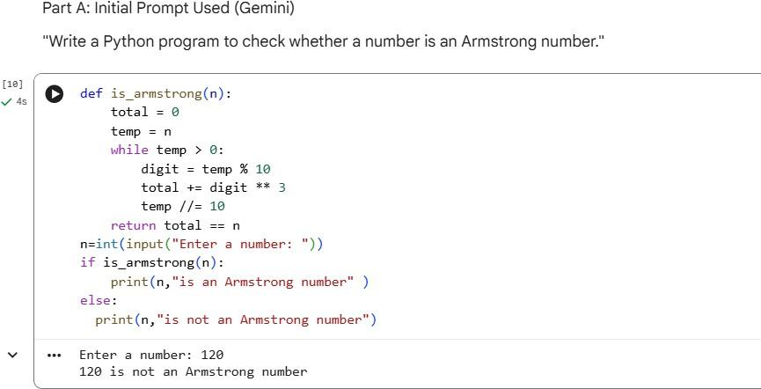
Problems in Initial Version:
  - Power is fixed to 3, works only for 3-digit numbers.
  - No handling for negative numbers.
  - Not generalized for any digit length.

IMPROVEMENT CODE OF CURSOR AI:
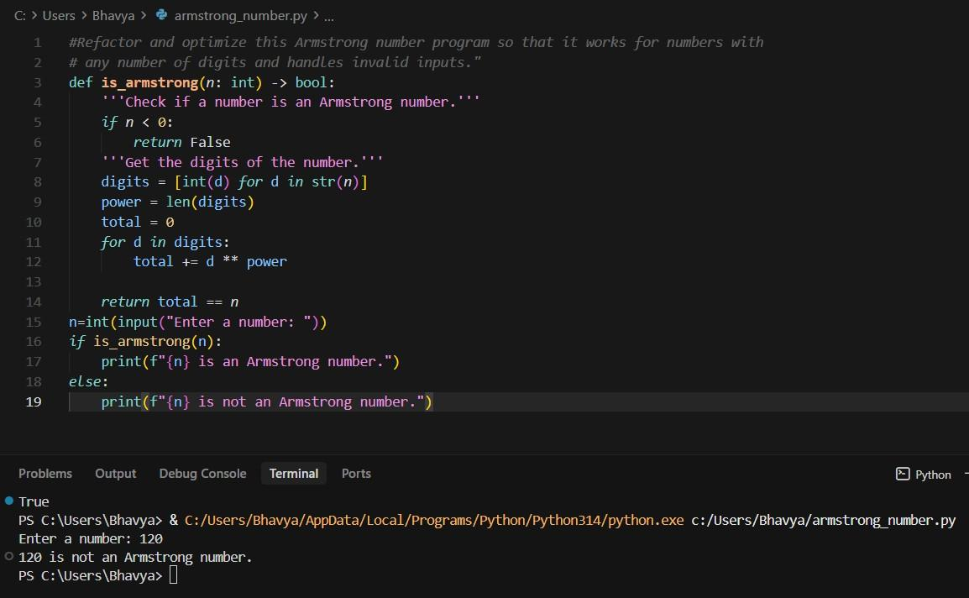

Summary of Improvements:
  - Works for any number of digits.
  - Handles negative numbers.
  - Uses digit length dynamically.
  - More general and reliable algorithm.
Conclusion:

  - Cursor AI significantly improved correctness and generality of the original Gemini solution.

